# 2017 Observing Notes

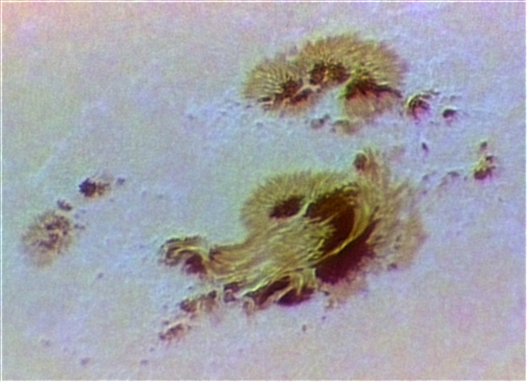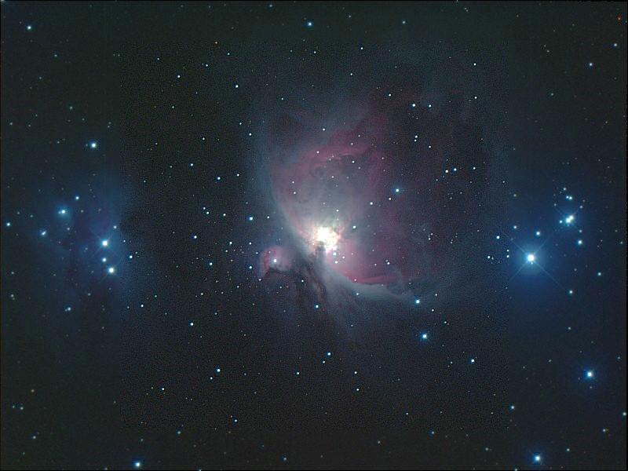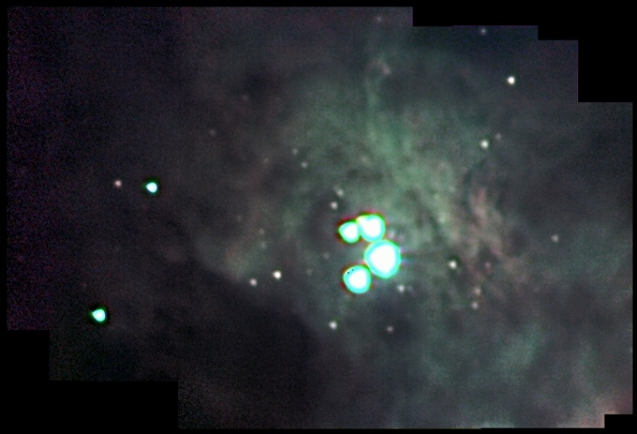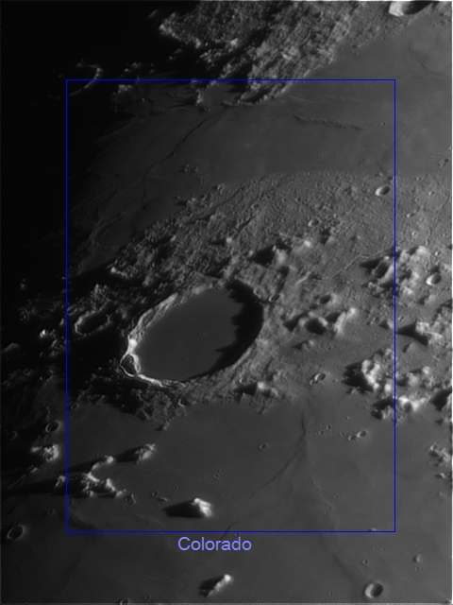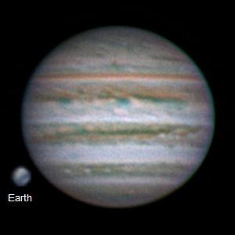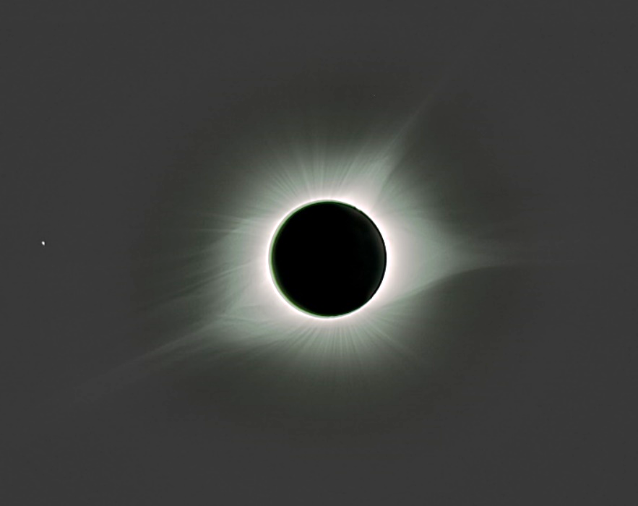

[2017 Observing Notes 1](#_Toc492877207)

[Year in Review 3](#_Toc492877208)

[January 4](#_Toc492877209)

[2017-Jan-17 (Jan-18 UT): M42 in 889nm CH4 4](#_Toc492877210)

[2017-Jan-18 (Jan-19 UT): M33 in 889nm CH4 and M42 in >685nm NIR and 889nm CH4 5](#_Toc492877211)

[2017-Jan-19 (Jan-20 UT): M33 in 380nm NUV 7](#_Toc492877212)

[February 8](#_Toc492877213)

[2017-Feb-20 (Feb-21 UT): M42 RGB 8](#_Toc492877214)

[March 9](#_Toc492877215)

[Spring 2017 Planning 9](#_Toc492877216)

[2017-Mar-15 (Mar-15&16 UT): Venus, M42 and NGC2392 Video 10](#_Toc492877217)

[April 13](#_Toc492877218)

[2017-Apr-12 (Apr-13 UT): Jupiter, Io, Europa and Ganymede 13](#_Toc492877219)

[2017-Apr-13 (Apr-14 UT): Jupiter 16](#_Toc492877220)

[May 18](#_Toc492877221)

[2017-May-04 (May-05 UT): Jupiter, Io, Europa and Moon 18](#_Toc492877222)

[2017-May-24 (May-25 UT): Jupiter, Io, Europa and Ganymede 23](#_Toc492877223)

[June 26](#_Toc492877224)

[2017-Jun-04 (Jun-05 UT): Jupiter, Io and Moon 26](#_Toc492877225)

[2017-Jun-14 (Jun-15 UT): Jupiter, Europa and Ganymede 28](#_Toc492877226)

[2017-Jun-15 (Jun-16 UT): Jupiter, Saturn 30](#_Toc492877227)

[July 32](#_Toc492877228)

[Summer 2017 Planning 32](#_Toc492877229)

[August 34](#_Toc492877230)

[2017-Aug-01 (Aug-02 UT): Moon and Saturn 34](#_Toc492877231)

[2017-Aug-18 (Aug-18 UT): Sun Imaging Tests 38](#_Toc492877232)

[2017-Aug-21 (Aug-21 UT): Eclipse in Alliance, Nebraska! 39](#_Toc492877233)

[2017-Aug-28 (Aug-29 UT): Saturn Video 42](#_Toc492877234)

[Fall 2017 Planning 43](#_Toc492877235)

[September 44](#_Toc492877236)

[2017-Sep-06 (Sep-06 UT): Sun – AR 12673 44](#_Toc492877237)

## Year in Review

Multiband, deep sky imaging…

High-resolution Jupiter imaging with a focus on weather…

## January

### 2017-Jan-17 (Jan-18 UT): M42 in 889nm CH4

Last Updated 1/23/2017

TBD

|  |  |
| --- | --- |
| F:\Astronomy\Projects\Nebulae-Diffuse\M42 - Orion Nebula\Imaging Data\20170118UT-430mm\M42-20170118UT-889CH4a-sum02h47m30s-Artifact-Flattened-Log-HalfSize.jpg | F:\Astronomy\Projects\Nebulae-Diffuse\M42 - Orion Nebula\Imaging Data\20170118UT-430mm\M42-201XXXXXUT-889CH4-sum05h45m00s-Artifact-Flattened-Log-HalfSize.jpg |
| M42-20170118UT-889CH4a-sum02h47m30s-Artifact-Flattened-Log-HalfSize.jpg | M42-201XXXXXUT-889CH4-sum05h45m00s-Artifact-Flattened-Log-HalfSize.jpg |
| F:\Astronomy\Projects\Nebulae-Diffuse\M42 - Orion Nebula\Imaging Data\20170118UT-430mm\M42-201X-RGB-TestNIR-HalfSize.jpg |  |
| M42-201X-RGB-TestNIR-HalfSize.jpg |  |

**Data Disposition:** Raw data are zipped and on the 2TB archive drive. Processed data are under the Projects directory on the Astronomy thumb drive.

### 2017-Jan-18 (Jan-19 UT): M33 in 889nm CH4 and M42 in >685nm NIR and 889nm CH4

Last Updated 1/23/2017

TBD

|  |  |
| --- | --- |
| F:\Astronomy\Projects\Galaxies\M33\Imaging Data\20170119UT\M33-20170119UT-889CH4a-sum01h22m30s-Flattened-Lin-HalfSize.jpg | F:\Astronomy\Projects\Galaxies\M33\Imaging Data\20170119UT\M33-201XXXXXUT-889CH4-sum03h02m15s-WCS-Artifacts-Lin-HalfSize.jpg |
| M33-20170119UT-889CH4a-sum01h22m30s-Flattened-Lin-HalfSize.jpg | M33-201XXXXXUT-889CH4-sum03h02m15s-WCS-Artifacts-Lin-HalfSize.jpg |

|  |  |
| --- | --- |
| F:\Astronomy\Projects\Nebulae-Diffuse\M42 - Orion Nebula\Imaging Data\20170119UT-430mm\M42-20170119UT-685NIR-sum29m36s-Flattened-Log-HalfSize.jpg | F:\Astronomy\Projects\Nebulae-Diffuse\M42 - Orion Nebula\Imaging Data\20170119UT-430mm\M42-201XXXXXUT-685NIR-sum34m43s-Flattened-Log-HalfSize.jpg |
| M42-20170119UT-685NIR-sum29m36s-Flattened-Log-HalfSize.jpg | M42-201XXXXXUT-685NIR-sum34m43s-Flattened-Log-HalfSize.jpg |
| F:\Astronomy\Projects\Nebulae-Diffuse\M42 - Orion Nebula\Imaging Data\20170119UT-430mm\M42-20170119UT-889CH4a-sum01h55m-Flattened-Log-HalfSize.jpg | F:\Astronomy\Projects\Nebulae-Diffuse\M42 - Orion Nebula\Imaging Data\20170119UT-430mm\M42-201XXXXXUT-889CH4-sum07h40m-Flattened-Log-HalfSize.jpg |
| M42-20170119UT-889CH4a-sum01h55m-Flattened-Log-HalfSize.jpg | M42-201XXXXXUT-889CH4-sum07h40m-Flattened-Log-HalfSize.jpg |

**Data Disposition:** TBD.

### 2017-Jan-19 (Jan-20 UT): M33 in 380nm NUV

Last Updated 1/23/2017

TBD

|  |  |
| --- | --- |
| F:\Astronomy\Projects\Galaxies\M33\Imaging Data\20170120UT\M33-20170120UT-380NUV-sum01h23m-Flattened-Lin-HalfSize.jpg | F:\Astronomy\Projects\Galaxies\M33\Imaging Data\20170120UT\M33-201XXXXXUT-380NUV-sum6h55m30s-Flattened-WCS-Smoothed-Lin-HalfSize.jpg |
| M33-20170120UT-380NUV-sum01h23m-Flattened-Lin-HalfSize.jpg | M33-201XXXXXUT-380NUV-sum6h55m30s-Flattened-WCS-Smoothed-Lin-HalfSize.jpg |

**Data Disposition:** Raw data zipped on Astronomy laptop ready to move to 2TB archive drive. Processed data resides on the Astrothumb2 thumb drive.

## February

### 2017-Feb-20 (Feb-21 UT): M42 RGB

Last Updated 1/23/2017

TBD

|  |  |
| --- | --- |
| F:\Astronomy\Projects\Nebulae-Diffuse\M42 - Orion Nebula\Imaging Data\20170221UT-430mm\M42-20170221UT-650RED-sum0h55m-Artifacts-Flattened-Log-HalfSize.jpg | F:\Astronomy\Projects\Nebulae-Diffuse\M42 - Orion Nebula\Imaging Data\20170221UT-430mm\M42-20170221UT-550GRN-sum0h30m-Flattened-Log-HalfSize.jpg |
| M42-20170221UT-650RED-sum0h55m-Artifacts-Flattened-Log-HalfSize.jpg | M42-20170221UT-550GRN-sum0h30m-Flattened-Log-HalfSize.jpg |
| F:\Astronomy\Projects\Nebulae-Diffuse\M42 - Orion Nebula\Imaging Data\20170221UT-430mm\M42-20170221UT-450BLU-sum0h30m-Flattened-Log-HalfSize.jpg | F:\Astronomy\Projects\Nebulae-Diffuse\M42 - Orion Nebula\Imaging Data\20170221UT-430mm\M42-20170221UT-LRGB-HalfSize-Stretched-Sat150pct-Wavelets1x5Maskedt.jpg |
| M42-20170221UT-450BLU-sum0h30m-Flattened-Log-HalfSize.jpg | M42-20170221UT-LRGB-HalfSize-Stretched-Sat150pct-Wavelets1x5Maskedt.jpg |

**Data Disposition:** Raw data zipped on Astronomy laptop ready to move to 2TB archive drive. Processed data resides on the Astrothumb2 thumb drive. VERIFY MOVED TO 2B DRIVE.

## March

### Spring 2017 Planning

Last Updated 1/23/2017

* Observations
  + Spectra
    - Venus
    - Eskimo
    - Jupiter
    - 3C273
  + Video
    - Venus
    - Mars
    - Uranus
    - M42
    - Eskimo
    - Jupiter
    - Sirius (other double stars?)
  + Imaging
    - M81
    - M101

### 2017-Mar-15 (Mar-15&16 UT): Venus, M42 and NGC2392 Video

Last Updated 3/16/2017

This was the first set of imaging observations since reconfiguring the telescope to the C8-135mm lens set up from the TKE130 set up. However, I did do a visual observation with Nathan a couple of weeks earlier when we looked at Venus, Mars and the Moon.

Venus

|  |  |
| --- | --- |
| F:\Astronomy\Projects\Planets\Venus\Imaging Data\20170315UT\2017-03-16-0041_2-Venus_807NIR-Stack500-Wwavelets1x5+2x10+3x5+Contrast80pct.jpg | F:\Astronomy\Projects\Planets\Venus\Imaging Data\20170315UT\Venus-20170315UT-889CH4-LongStack-Flattened-Wavelets-Cropped.jpg |
| 2017-03-16-0041\_2-Venus\_807NIR-Stack500-Wwavelets1x5+2x10+3x5+Contrast80pct.jpg | Venus-20170315UT-889CH4-LongStack-Flattened-Wavelets-Cropped.jpg |

The attempt to image Venus’s night-side surface was not successful. This is due, I believe, to the terrestrial sky brightness in the 889nm filter band more than to reduced thermal emission from Venus in this band. It would probably be worthwhile to obtain a 1.0μm filter for the next attempt. Alternatively, perhaps a filter at approximately 970nm would be useful also as a “window” filter to compare to 889nm methane images of outer planets.

M42

|  |  |
| --- | --- |
| F:\Astronomy\Projects\Nebulae-Diffuse\M42 - Orion Nebula\Imaging Data\20170316UT\M42-20170316UT-650RED-Mosaic-Gam70pct.jpg | F:\Astronomy\Projects\Nebulae-Diffuse\M42 - Orion Nebula\Imaging Data\20170316UT\M42-20170316UT-550GRN-Mosaic-Gam70pct.jpg |
| M42-20170316UT-650RED-Mosaic-Gam70pct.jpg | M42-20170316UT-550GRN-Mosaic-Gam70pct.jpg |
| F:\Astronomy\Projects\Nebulae-Diffuse\M42 - Orion Nebula\Imaging Data\20170316UT\M42-20170316UT-450BLU-Mosaic-Gam70pct.jpg | F:\Astronomy\Projects\Nebulae-Diffuse\M42 - Orion Nebula\Imaging Data\20170316UT\M42-20170316UT-550CLR-Mosaic-Gam70pct.jpg |
| M42-20170316UT-450BLU-Mosaic-Gam70pct.jpg | M42-20170316UT-550CLR-Mosaic-Gam70pct.jpg |
| F:\Astronomy\Projects\Nebulae-Diffuse\M42 - Orion Nebula\Imaging Data\20170316UT\M42-20170316UT-X50-LRGB-Wavelets-ColBal-Gam70pct.jpg |  |
| M42-20170316UT-X50-LRGB-Wavelets-ColBal-Gam70pct.jpg |  |

Attempts to navigate these images using PinPoint astrometry in MaximDL failed. In addition, attempts to manually navigate these images in Aladin failed. In both cases, this is likely due to the very large saturated images of the Trapezium stars. Some sort of alternative, even more manual approach – probably iterative – must be tried. It would be terrific to have this navigation completed so that catalog info could be overlaid, in particular HH and proplyd data.

NGC2392

|  |  |
| --- | --- |
| F:\Astronomy\Projects\Nebulae-Planetary\NGC2392\Imaging Data\20170316UT\2017-03-16-0344_2-NGC2392_550CLR_V1-Stack452-Wavelets2x2+3x4+4x2-Avg-Gam2-Stretch20-255-Wavelets.jpg | F:\Astronomy\Projects\Nebulae-Planetary\NGC2392\Imaging Data\20170316UT\2017-03-16-0413_2-NGC2392_550CLR_V2-Stack151-Wavelets2x3+3x6+4x3-Stretch10-128.jpg |
| 2017-03-16-0344\_2-NGC2392\_550CLR\_V1-Stack452-Wavelets2x2+3x4+4x2-Avg-Gam2-Stretch20-255-Wavelets.jpg | 2017-03-16-0413\_2-NGC2392\_550CLR\_V2-Stack151-Wavelets2x3+3x6+4x3-Stretch10-128.jpg |
| F:\Astronomy\Projects\Nebulae-Planetary\NGC2392\Imaging Data\20170316UT\2017-03-16-0344_2-NGC2392_550CLR_VX-Hybrid-Stack653-WaveletsV2.jpg |  |
| 2017-03-16-0344\_2-NGC2392\_550CLR\_VX-Hybrid-Stack653-WaveletsV2.jpg |  |

## April

### 2017-Apr-12 (Apr-13 UT): Jupiter, Io, Europa and Ganymede

Last Updated 4/20/2017

Very good seeing. Very transparent sky. Linear gamma on 889CH4!

|  |  |
| --- | --- |
| F:\Astronomy\Projects\Planets\Jupiter\Imaging Data\20170413UT\2017-04-13-0410_3-Hill-Jupiter-RGB-Wavelets.jpg | F:\Astronomy\Projects\Planets\Jupiter\Imaging Data\20170413UT\2017-04-13-0414_6-Hill-Jupiter-RED-685-807-Wavelets.jpg |
| 2017-04-13-0410\_3-Hill-Jupiter-RGB-Wavelets.jpg | 2017-04-13-0414\_6-Hill-Jupiter-RED-685-807-Wavelets.jpg |
| F:\Astronomy\Projects\Planets\Jupiter\Imaging Data\20170413UT\2017-04-13-0415_8-Hill-Jupiter-889-GRN-BLU-Wavelets.jpg |  |
| 2017-04-13-0415\_8-Hill-Jupiter-889-GRN-BLU-Wavelets.jpg |  |

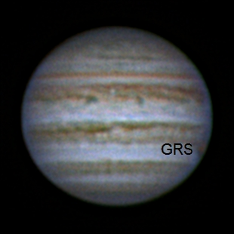

2017-04-13-0410\_3-Hill-Jupiter-RGB-Wavelets-Annotated.jpg

|  |  |  |
| --- | --- | --- |
| F:\Astronomy\Projects\Planets\Jupiter\Imaging Data\20170413UT\2017-04-13-0448_8-Io+Europa_685-IoStack60-Wavelets1x15+2x5-IoCrop-2x.jpg | F:\Astronomy\Projects\Planets\Jupiter\Imaging Data\20170413UT\2017-04-13-0448_8-Io+Europa_685-EuropaStack60-Wavelets1x15+2x5-EuropaCrop-2x.jpg | F:\Astronomy\Projects\Planets\Jupiter\Imaging Data\20170413UT\2017-04-13-0453_3-Ganymede_685-Stack200-Wavelets1x30+2x15-Crop-2x.jpg |
| 2017-04-13-0448\_8-Io+Europa\_685-IoStack60-Wavelets1x15+2x5-IoCrop-2x.jpg | 2017-04-13-0448\_8-Io+Europa\_685-EuropaStack60-Wavelets1x15+2x5-EuropaCrop-2x.jpg | 2017-04-13-0453\_3-Ganymede\_685-Stack200-Wavelets1x30+2x15-Crop-2x.jpg |

QuickMoonsRSSAnalysis.xlsx



Two videos were taken, one of Io and Europa together and the other of Ganymede. Using the relative positions of Io and Europa the astrometrically determined plate scale was found to be 0.1734 arcsec-pixel-1.

Assuming the observed size of the satellites to represent the actual size added in quadrature with a Gaussian representing system resolution, one can compute that resolution. In the case here, the observed size of Ganymede is smaller than the expected size (if FWHM is a good representation of size!) and so is not considered in the calculations. Using only Io and Europa, we find the system resolution to be 0.694±0.040 arcsec (95% confidence). This is consistent with the visual appearance of the Jupiter images in the same spectral band. Note that the estimated resolution determined independent of the plate scale not very consistent at 1.090 arcsec.

**Data Disposition:** Raw data are zipped and on the 2TB archive drive. Processed data are under the Projects directory on the Astronomy thumb drive.

### 2017-Apr-13 (Apr-14 UT): Jupiter

Last Updated 4/20/2017

Moderate seeing. **High and variable clouds**. Linear gamma on 889CH4!

|  |  |
| --- | --- |
| F:\Astronomy\Projects\Planets\Jupiter\Imaging Data\20170414UT\2017-04-14-0402_8-Hill-Jupiter-RGB-Wavelets.jpg | F:\Astronomy\Projects\Planets\Jupiter\Imaging Data\20170414UT\2017-04-14-0406_5-Hill-Jupiter-807-685-RED-Wavelets.jpg |
| 2017-04-14-0402\_8-Hill-Jupiter-RGB-Wavelets.jpg | 2017-04-14-0406\_5-Hill-Jupiter-807-685-RED-Wavelets.jpg |
| F:\Astronomy\Projects\Planets\Jupiter\Imaging Data\20170414UT\2017-04-14-0413_1-Hill-Jupiter-889-GRN-NUV-Wavelets.jpg |  |
| 2017-04-14-0413\_1-Hill-Jupiter-889-GRN-NUV-Wavelets.jpg |  |

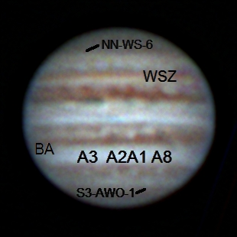

2017-04-14-0402\_8-Hill-Jupiter-RGB-Wavelets-Annotated.jpg

**Data Disposition:** Raw data are zipped and on the 2TB archive drive. Processed data are under the Projects directory on the Astronomy thumb drive.

## May

### 2017-May-04 (May-05 UT): Jupiter, Io, Europa and Moon

Last Updated 4/20/2017

Very steady seeing (4.5/5!?) and very good transparency. Linear gamma on CH4 and NUV.

|  |  |
| --- | --- |
| F:\Astronomy\Projects\Planets\Jupiter\Imaging Data\20170505UT\2017-05-05-0336_1-Hill-Jupiter-RGB-WhtBal-Stretch-0to192-Wavelets.png | F:\Astronomy\Projects\Planets\Jupiter\Imaging Data\20170505UT\2017-05-05-0341_7-Hill-Jupiter-807-685-RED-WhtBal-Sat200pct-Wavelets.png |
| 2017-05-05-0336\_1-Hill-Jupiter-RGB-WhtBal-Stretch-0to192-Wavelets.png | 2017-05-05-0341\_7-Hill-Jupiter-807-685-RED-WhtBal-Sat200pct-Wavelets.png |
| F:\Astronomy\Projects\Planets\Jupiter\Imaging Data\20170505UT\2017-05-05-0351_2-Hill-Jupiter-889-GRN-NUV-ColBal-Wavelets.png | F:\Astronomy\Projects\Planets\Jupiter\Imaging Data\20170505UT\2017-05-05-0347_6-Hill-Jupiter-807-GRN-NUV-WhtBal-Wavelets.png |
| 2017-05-05-0351\_2-Hill-Jupiter-889-GRN-NUV-ColBal-Wavelets.png | 2017-05-05-0347\_6-Hill-Jupiter-807-GRN-NUV-WhtBal-Wavelets.png |

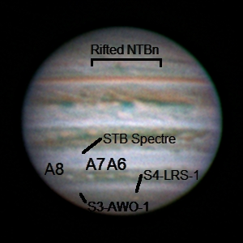

|  |  |  |  |
| --- | --- | --- | --- |
| F:\Astronomy\Projects\Planets\Jupiter\Imaging Data\20170505UT\2017-05-05-0348_2-Jupiter_685NIR_Full-IoAligned-Stack50-Wavelets1x10+2x5-Cropped-2x.jpg | F:\Astronomy\Projects\Planets\Jupiter\Imaging Data\20170505UT\2017-05-05-0347_3-Jupiter_685NIR_Full-IoAligned-Stack100-Stretch0to64-Wavelets1x10+2x5-Cropped-2x.jpg | F:\Astronomy\Projects\Planets\Jupiter\Imaging Data\20170505UT\2017-05-05-0348_2-Jupiter_685NIR_Full-EuropaAligned-Stack40-Wavelets1x10+2x5-Cropped-2x.jpg | F:\Astronomy\Projects\Planets\Jupiter\Imaging Data\20170505UT\2017-05-05-0347_3-Jupiter_685NIR_Full-EuropaAligned-Stack100-Stretch0to64-Wavelets1x10+2x5-Cropped-2x.jpg |
| 2017-05-05-0348\_2-Jupiter\_685NIR\_Full-IoAligned-Stack50-Wavelets1x10+2x5-Cropped-2x.jpg | 2017-05-05-0347\_3-Jupiter\_685NIR\_Full-IoAligned-Stack100-Stretch0to64-Wavelets1x10+2x5-Cropped-2x.jpg | 2017-05-05-0348\_2-Jupiter\_685NIR\_Full-EuropaAligned-Stack40-Wavelets1x10+2x5-Cropped-2x.jpg | 2017-05-05-0347\_3-Jupiter\_685NIR\_Full-EuropaAligned-Stack100-Stretch0to64-Wavelets1x10+2x5-Cropped-2x.jpg |

20170505T0347.3UT



20170505T0348.2UT



Two videos were taken, one at 0347.3UT and the other at 0348.2UT. The first one used very short exposures with a linear gamma. The other used much longer exposures. Using the relative positions of Io and Europa the astrometrically determined plate scale was found to be 0.1726±0.002 arcsec-pixel-1. This is very close to the previously determined 0.1734 arcsec-pixel-1 determined from 20170414UT (about a 0.46% difference).

The difference between the two videos is evident in the effective system resolution. For the short exposures at 0347.3UT the resolution is 0.580±0.040 arcsec (95% confidence). For the long exposures at 0348.2UT the resolution is 0.815±0.019 arcsec. Note that the estimated resolution determined independent of the plate scale pretty consistent at 0.860 and 0.728 arcsec.

**Data Disposition:** Raw data are zipped and on the 2TB archive drive. Processed data are under the Projects directory on the Astronomy thumb drive.

|  |  |
| --- | --- |
| F:\Astronomy\Projects\Moon\Imaging Data\20170505UT\2017-05-05-0410_6-Moon_685NIR-CraterCentered-Stack200-Wavelets1x15+2x10-Gamma1.3-HalfSize.jpg | F:\Astronomy\Projects\Moon\Imaging Data\20170505UT\2017-05-05-0412_7-Moon_685NIR-StraightWallAligned-Stack200-Wavelets1x15+2x10-HalfSize.jpg |
| 2017-05-05-0410\_6-Moon\_685NIR-CraterCentered-Stack200-Wavelets1x15+2x10-Gamma1.3-HalfSize.jpg | 2017-05-05-0412\_7-Moon\_685NIR-StraightWallAligned-Stack200-Wavelets1x15+2x10-HalfSize.jpg |
| F:\Astronomy\Projects\Moon\Imaging Data\20170505UT\2017-05-05-0410_6-Moon_685NIR-CraterCentered-Stack200-Wavelets1x15+2x10-Gamma1.3-HalfSize.jpg | F:\Astronomy\Projects\Moon\Imaging Data\20170505UT\2017-05-05-0412_7-Moon_685NIR-StraightWallAligned-Stack200-Wavelets1x15+2x10-HalfSize.jpg |
| 2017-05-05-0410\_6-Moon\_685NIR-CraterCentered-Stack200-Wavelets1x15+2x10-Gamma1.3-HalfSize.jpg | 2017-05-05-0412\_7-Moon\_685NIR-StraightWallAligned-Stack200-Wavelets1x15+2x10-HalfSize.jpg |

|  |  |
| --- | --- |
| F:\Astronomy\Projects\Moon\Imaging Data\20170505UT\2017-05-05-0415_3-Moon_685NIR-ClaviusAligned-Stack200-Wavelets1x15+2x10-Gamma1.3-HalfSize.jpg | F:\Astronomy\Projects\Moon\Imaging Data\20170505UT\2017-05-05-0419_7-Moon_685NIR-PlatoAligned-Stack200-Wavelets1x15+2x10-Gamma1.3-HalfSize.jpg |
| 2017-05-05-0415\_3-Moon\_685NIR-ClaviusAligned-Stack200-Wavelets1x15+2x10-Gamma1.3-HalfSize.jpg | 2017-05-05-0419\_7-Moon\_685NIR-PlatoAligned-Stack200-Wavelets1x15+2x10-Gamma1.3-HalfSize.jpg |

### 2017-May-24 (May-25 UT): Jupiter, Io, Europa and Ganymede

Last Updated 5/26/2017

Very steady seeing (4.5/5!?) and very good transparency. Linear gamma on CH4 and NUV.

|  |  |
| --- | --- |
| F:\Astronomy\Projects\Planets\Jupiter\Imaging Data\20170525UT\2017-05-25-0432_1-Hill-Jupiter-RGB-Wavelets-Stuff.png | F:\Astronomy\Projects\Planets\Jupiter\Imaging Data\20170525UT\2017-05-25-0436_5-Hill-Jupiter-807-685-RED-Wavelets.png |
| 2017-05-25-0432\_1-Hill-Jupiter-RGB-Wavelets-Stuff.png | 2017-05-25-0436\_5-Hill-Jupiter-807-685-RED-Wavelets.png |
| F:\Astronomy\Projects\Planets\Jupiter\Imaging Data\20170525UT\2017-05-25-0444_6-Hill-Jupiter-CH4-GRN-NUV-Wavelets-Stuff.png | F:\Astronomy\Projects\Planets\Jupiter\Imaging Data\20170525UT\2017-05-25-0442_3-Hill-Jupiter-807-GRN-NUV-Wavelets.png |
| 2017-05-25-0444\_6-Hill-Jupiter-CH4-GRN-NUV-Wavelets-Stuff.png | 2017-05-25-0442\_3-Hill-Jupiter-807-GRN-NUV-Wavelets.png |

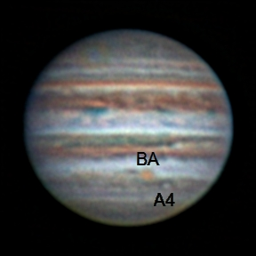

2017-05-25-0432\_1-Hill-Jupiter-RGB-Wavelets-Stuff-Annotated.jpg

|  |  |  |  |
| --- | --- | --- | --- |
| F:\Astronomy\Projects\Planets\Jupiter\Imaging Data\20170505UT\2017-05-05-0348_2-Jupiter_685NIR_Full-IoAligned-Stack50-Wavelets1x10+2x5-Cropped-2x.jpg | F:\Astronomy\Projects\Planets\Jupiter\Imaging Data\20170505UT\2017-05-05-0347_3-Jupiter_685NIR_Full-IoAligned-Stack100-Stretch0to64-Wavelets1x10+2x5-Cropped-2x.jpg | F:\Astronomy\Projects\Planets\Jupiter\Imaging Data\20170505UT\2017-05-05-0348_2-Jupiter_685NIR_Full-EuropaAligned-Stack40-Wavelets1x10+2x5-Cropped-2x.jpg | F:\Astronomy\Projects\Planets\Jupiter\Imaging Data\20170505UT\2017-05-05-0347_3-Jupiter_685NIR_Full-EuropaAligned-Stack100-Stretch0to64-Wavelets1x10+2x5-Cropped-2x.jpg |
| 2017-05-05-0348\_2-Jupiter\_685NIR\_Full-IoAligned-Stack50-Wavelets1x10+2x5-Cropped-2x.jpg | 2017-05-05-0347\_3-Jupiter\_685NIR\_Full-IoAligned-Stack100-Stretch0to64-Wavelets1x10+2x5-Cropped-2x.jpg | 2017-05-05-0348\_2-Jupiter\_685NIR\_Full-EuropaAligned-Stack40-Wavelets1x10+2x5-Cropped-2x.jpg | 2017-05-05-0347\_3-Jupiter\_685NIR\_Full-EuropaAligned-Stack100-Stretch0to64-Wavelets1x10+2x5-Cropped-2x.jpg |

20170505T0347.3UT



20170505T0348.2UT



Two videos were taken, one at 0347.3UT and the other at 0348.2UT. The first one used very short exposures with a linear gamma. The other used much longer exposures. Using the relative positions of Io and Europa the astrometrically determined plate scale was found to be 0.1726±0.002 arcsec-pixel-1. This is very close to the previously determined 0.1734 arcsec-pixel-1 determined from 20170414UT (about a 0.46% difference).

The difference between the two videos is evident in the effective system resolution. For the short exposures at 0347.3UT the resolution is 0.580±0.040 arcsec (95% confidence). For the long exposures at 0348.2UT the resolution is 0.815±0.019 arcsec. Note that the estimated resolution determined independent of the plate scale pretty consistent at 0.860 and 0.728 arcsec.

**Data Disposition:** Raw data are zipped and on the 2TB archive drive. Processed data are under the Projects directory on the Astronomy thumb drive.

## June

### 2017-Jun-04 (Jun-05 UT): Jupiter, Io and Moon

Last Updated 6/5/2017

Very steady seeing (4.5/5!?) and very good transparency. Linear gamma on CH4 and NUV.

|  |  |
| --- | --- |
| F:\Astronomy\Projects\Planets\Jupiter\Imaging Data\20170605UT\2017-06-05-0329_8-Hill-Jupiter-RGB-Wavelets.png | F:\Astronomy\Projects\Planets\Jupiter\Imaging Data\20170605UT\2017-06-05-0333_6-Hill-Jupier-807-685-RED-Wavelets.png |
| 2017-06-05-0329\_8-Hill-Jupiter-RGB-Wavelets.png | 2017-06-05-0333\_6-Hill-Jupier-807-685-RED-Wavelets.png |
| F:\Astronomy\Projects\Planets\Jupiter\Imaging Data\20170605UT\2017-06-05-0340_1-Hill-Jupiter-CH4-GRN-NUV-Wavelets.png | F:\Astronomy\Projects\Planets\Jupiter\Imaging Data\20170605UT\2017-06-05-0338_4-Hill-807-GRN-NUV-Wavelets.png |
| 2017-06-05-0340\_1-Hill-Jupiter-CH4-GRN-NUV-Wavelets.png | 2017-06-05-0338\_4-Hill-807-GRN-NUV-Wavelets.png |

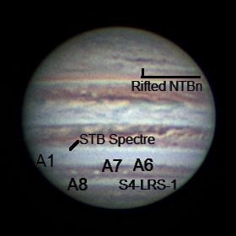

2017-06-05-0329\_8-Hill-Jupiter-RGB-Wavelets-Annotated

### 2017-Jun-14 (Jun-15 UT): Jupiter, Europa and Ganymede

Last Updated 6/5/2017

First time with new Dell Inspiron 13. Worked very well. Upgraded SharpCap 3.X wanted to take LX videos and save as a sequence of PNGs. Not sure how to get past that right now. Aha, I can use MaximDL to make AVI files from the individual PNGs. I tried it and then stacked the AVI successfully in Registax.

|  |  |
| --- | --- |
| C:\Users\Steven Hill\AppData\Local\Microsoft\Windows\INetCache\Content.Word\2017-06-15-0319_8-Hill-Jupiter-RGB-Wavelets.jpg | C:\Users\Steven Hill\AppData\Local\Microsoft\Windows\INetCache\Content.Word\2017-06-15-0325_7-Hill-Jupiter-807-685-RED-Wavelets.jpg |
| 2017-06-15-0319\_8-Hill-Jupiter-RGB-Wavelets.jpg | 2017-06-15-0325\_7-Hill-Jupiter-807-685-RED-Wavelets.jpg |
| C:\Users\Steven Hill\AppData\Local\Microsoft\Windows\INetCache\Content.Word\2017-06-15-0337_9-Hill-Jupiter-CH4-GRN-NUV-Wavelets.jpg | C:\Users\Steven Hill\AppData\Local\Microsoft\Windows\INetCache\Content.Word\2017-06-15-0334_0-Hill-Jupiter-807-GRN-NUV-Wavelets.jpg |
| 2017-06-15-0337\_9-Hill-Jupiter-CH4-GRN-NUV-Wavelets.jpg | 2017-06-15-0334\_0-Hill-Jupiter-807-GRN-NUV-Wavelets |

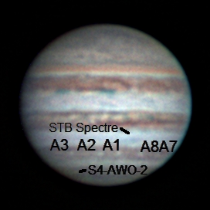

2017-06-15-0319\_8-Hill-Jupiter-RGB-Wavelets-Annotated.jpg

### 2017-Jun-15 (Jun-16 UT): Jupiter, Saturn

Last Updated 6/5/2017

Very steady seeing (4.5/5!?) and very good transparency. Linear gamma on CH4 and NUV.

|  |  |
| --- | --- |
| C:\Users\Steven Hill\AppData\Local\Microsoft\Windows\INetCache\Content.Word\2017-06-16-0423_9-Hill-Jupiter-Composit-Wavelets.jpg | C:\Users\Steven Hill\AppData\Local\Microsoft\Windows\INetCache\Content.Word\2017-06-16-0428_9-Hill-Jupiter-807-685-RED-Composite-Wavelets.png |
| 2017-06-16-0423\_9-Hill-Jupiter-Composit-Wavelets.jpg | 2017-06-16-0428\_9-Hill-Jupiter-807-685-RED-Composite-Wavelets.jpg |
| C:\Users\Steven Hill\AppData\Local\Microsoft\Windows\INetCache\Content.Word\2017-06-16-0437_1-Hill-Jupiter-889-GRN-NUV-Composite-Wavelets.jpg | C:\Users\Steven Hill\AppData\Local\Microsoft\Windows\INetCache\Content.Word\2017-06-16-0434_4-Hill-Jupiter-807-GRN-NUV-Composite-Wavelets.jpg |
| 2017-06-16-0437\_1-Hill-Jupiter-889-GRN-NUV-Composite-Wavelets.jpg | 2017-06-16-0434\_4-Hill-Jupiter-807-GRN-NUV-Composite-Wavelets |
|  |  |

NOTE: I NEED TO RECONCILE THE TIME TAGGING IN 889CH4 FILENAMES WITH THE MID-EXPOSURE TIMES. AND, THEN I NEED TO REDO FALSE COLOR RGB IMAGES USING 889CH4.

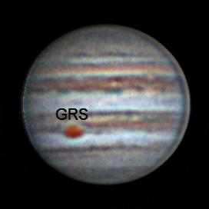

2017-06-16-0423\_9-Hill-Jupiter-Composit-Wavelets-Annotated.jpg

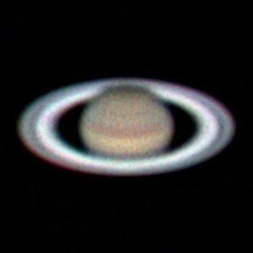

2017-06-16-0519\_6-Hill-Saturn-RGB-Wavelets.jpg

## July

### Summer 2017 Planning

Last Updated 1/23/2017

* Observations
  + Imaging
    - Eclipse
    - M101
    - NGC5907
    - NGC5985 – Draco Triple
    - NGC5905 – Draco Double
    - M8 - Lagoon
    - M21 - Trifid
    - M17 - Swan
    - M16 - Eagle
  + Video
    - Eclipse
    - Saturn
    - Cat’s Eye
    - Mu Dra
    - 61 Cyg
    - Zet Her – STF2085
    - 99 Her
    - Eps Lyr
    - BU 648
    - Lam Oph
    - 70 Oph
    - STF 2173
    - Del Serp
  + Spectra
    - Saturn
    - Titan (Sep 1UT good eastern elongation, Sep 06-10UT good western elongation)
    - Cat’s Eye
    - Bet Lyr 135mm x 200lpm
* Analysis
  + M31 Multispectral Analysis *ala* M33, M81, M101 etc.
  + Solar Eclipse Preparation
  + Questions for OPT:
    - Motorized Focuser
    - Custom Filters
    - NII filter

## August

### 2017-Aug-01 (Aug-02 UT): Moon and Saturn

Last Updated 8/6/2017

Very steady seeing (4/5) and very good transparency.

|  |  |
| --- | --- |
| C:\Users\Steven Hill\AppData\Local\Microsoft\Windows\INetCache\Content.Word\2017-08-02-0401_5-Hill-Saturn-RGB-Wavelets-WhtBal-Stuff.png |  |
| 2017-08-02-0401\_5-Hill-Saturn-RGB-Wavelets-WhtBal-Stuff.png | TBD |

|  |  |  |  |  |  |
| --- | --- | --- | --- | --- | --- |
| Filter | Gamma | Gain | Brightness | Exposure | LT |
| NUV | 50 | 100 | 0 | 3929 ms |  |
| BLU | 50 | 75 | 0 | 148 ms |  |
| GRN | 50 | 75 | 0 | 85 ms |  |
| RED | 50 | 75 | 0 | 148 ms |  |
| >685 | 50 | 75 | 0 | 87 ms |  |
| >807 | 50 | 75 | 0 | 374 ms |  |
| 889CH4 | 50 | 100 | 0 | 3929 ms |  |

For Saturn, I need to:

* Produce various combinations of RGB images
* Document videos and camera settings
* Identify which images have which moons visible
* Determine effects of gains settings for photometry of moons
* Do a polar map for the hexagon (maybe)
* Do a polar map for the rings
* Do an equatorial map for the bands.
* Archive data

For the Moon, I need to:

* Document videos and camera settings
* Attempt multi-focus alignment as opposed to single focus alignement
* Do some LTVT aerial projection maps
* Do some LTVT elevation measures
* Archive data

Moon Targets:

1. Copernicus
2. Plato and Imbrium (2x)
3. Alpine Valley and Cassini
4. Posidonius and dark flow of Serenitatis
5. Rima Hyginus
6. Pitatus and Hesiodus

Note that moon images were stacked with a single alignment area each focused on the feature of greatest interest, e.g., Plato.

|  |  |
| --- | --- |
| C:\Users\Steven Hill\AppData\Local\Microsoft\Windows\INetCache\Content.Word\2017-08-02-0220_5-Moon_685NIR-Stack350-Wavelets1x30+2x15-Gam50pct-HalfSize.jpg | C:\Users\Steven Hill\AppData\Local\Microsoft\Windows\INetCache\Content.Word\2017-08-02-0222_5-Moon_685NIR-Mosaic-HalfSize.jpg |
| 2017-08-02-0220\_5-Moon\_685NIR-Stack350-Wavelets1x30+2x15-Gam50pct-HalfSize.jpg | 2017-08-02-0222\_5-Moon\_685NIR-Mosaic-HalfSize.jpg |
| C:\Users\Steven Hill\AppData\Local\Microsoft\Windows\INetCache\Content.Word\2017-08-02-0224_7-Moon_685NIR-Stack500-Wavelets1x30+2x10-Gam80pct-HalfSize.jpg | C:\Users\Steven Hill\AppData\Local\Microsoft\Windows\INetCache\Content.Word\2017-08-02-0226_5-Moon_685NIR-Stack500-Wavelets1x20+1x20-Gam60pct-HalfSize.jpg |
| 2017-08-02-0224\_7-Moon\_685NIR-Stack500-Wavelets1x30+2x10-Gam80pct-HalfSize.jpg | 2017-08-02-0226\_5-Moon\_685NIR-Stack500-Wavelets1x20+1x20-Gam60pct-HalfSize.jpg |
| C:\Users\Steven Hill\AppData\Local\Microsoft\Windows\INetCache\Content.Word\2017-08-02-0228_4-Moon_685NIR-Stack500-Wavelets1x20+2x20-Gam60pct-HalfSize.jpg | C:\Users\Steven Hill\AppData\Local\Microsoft\Windows\INetCache\Content.Word\2017-08-02-0233_4-Moon_685NIR-Stack350-Wavelets1x20+2x20-Gam60pct-HalfSize.jpg |
| 2017-08-02-0228\_4-Moon\_685NIR-Stack500-Wavelets1x20+2x20-Gam60pct-HalfSize.jpg | 2017-08-02-0233\_4-Moon\_685NIR-Stack350-Wavelets1x20+2x20-Gam60pct-HalfSize.jpg |

**Data Disposition:** TBD

### 2017-Aug-18 (Aug-18 UT): Sun Imaging Tests

Last Updated 8/6/2017

Very steady seeing (4/5) and very good transparency.

|  |  |
| --- | --- |
| C:\Users\Steven Hill\AppData\Local\Microsoft\Windows\INetCache\Content.Word\2017-08-02-0401_5-Hill-Saturn-RGB-Wavelets-WhtBal-Stuff.png |  |
| 2017-08-02-0401\_5-Hill-Saturn-RGB-Wavelets-WhtBal-Stuff.png | TBD |

### 2017-Aug-21 (Aug-21 UT): Eclipse in Alliance, Nebraska!

Last Updated 8/6/2017

TO DO:

* Finish stacking all totality images from 500D – and document
* Create HDR master from 500D stacked images – and document
* Process all partial phase NIR video – and document
* Process all partial phase 500D images
* Make NIR Video
* Make 500D video
* Archive data

A wide range of images were taken using the Canon EOS Rebel 500D at 300mm and the ASI120MM with the 135mm lens and the >807nm NIR filter.

It would be a good idea to take some dark frames, flat fields and flux calibration images with known sources, e.g., sky for flats and Vega for flux with the different configurations used at the eclipse.

Notes on NIR images…

Very steady seeing (4/5) and very good transparency.

|  |  |
| --- | --- |
| C:\Users\Steven Hill\AppData\Local\Microsoft\Windows\INetCache\Content.Word\2017-08-21-1750_4-Sun_807NIR-Stack145-Gam3-Wavelets1x10+2x5+3x3+4x3-Color.jpg | C:\Users\Steven Hill\AppData\Local\Microsoft\Windows\INetCache\Content.Word\2017-08-21-1752_4-Sun_807NIR_Totality-Stack600-Gam2-Wavelets1x20+2x10+3x5+4x5-Color-Crop.jpg |
| 2017-08-21-1750\_4-Sun\_807NIR-Stack145-Gam3-Wavelets1x10+2x5+3x3+4x3-Color.jpg | 2017-08-21-1752\_4-Sun\_807NIR\_Totality-Stack600-Gam2-Wavelets1x20+2x10+3x5+4x5-Color-Crop.jpg |
| C:\Users\Steven Hill\AppData\Local\Microsoft\Windows\INetCache\Content.Word\2017-08-21-1752_4-Sun_807NIR_DiamondRing-Stack47-Gam2-Wavelets1x10+2x5-Color-Crop.jpg | C:\Users\Steven Hill\AppData\Local\Microsoft\Windows\INetCache\Content.Word\SXI-Stack3-Log-Filtered-Wavelets1-Rot-Color-Crop.jpg |
| 2017-08-21-1752\_4-Sun\_807NIR\_DiamondRing-Stack47-Gam2-Wavelets1x10+2x5-Color-Crop.jpg | SXI-Stack3-Log-Filtered-Wavelets1-Rot-Color-Crop.jpg |

**2017-08-21-1750\_4-Sun\_807NIR: Exposure=0.009433; Gain=50; Gamma=50**

This sequence only had 145 frames for a total exposure of 1.3678 seconds. I terminated it early once I realized I wasn’t capturing too much of the corona. Rather than increase exposure or gain, which would saturate the inner coronal, I increased gamma to near the maximum for the next sequence. However, with gamma set to 50 for this sequence, the response should be linear.

**2017-08-21-1752\_4-Sun\_807NIR: Exposure=0.009433; Gain=50; Gamma=95**

This sequence uses near maximum gamma. It is an extended sequence with 2253 frames. The sequence was initiated during totality and the first 600 frames cover totality for a total exposure of 5.6598 seconds. Frames from 650 to 697 show the diamond ring. Between 600 and 650 is a hard to characterize transition between totality and the diamond ring. Further examination may show a good example of Bailey’s Beads. At about frame 698 I replaced the NIR + 2xND filters to return to the partial phase. The last TBD frames show the crescent Sun.

|  |  |
| --- | --- |
| C:\Users\Steven Hill\AppData\Local\Microsoft\Windows\INetCache\Content.Word\Totality-20170821UT--0006-001ms-Aligned_thru_016ms-SmartMergeCurve-Wavelets2-Sat150-Crop-HalfSize.jpg | C:\Users\Steven Hill\AppData\Local\Microsoft\Windows\INetCache\Content.Word\Totality-20170821UT--0006-001ms-Aligned_thru_512ms-SmartMergeCurve-Gam-Wavelets2-Sat130pct-Crop-HalfSize.jpg |
| Totality-20170821UT--0006-001ms-Aligned\_thru\_016ms-SmartMergeCurve-Wavelets2-Sat150-Crop-HalfSize.jpg | Totality-20170821UT--0006-001ms-Aligned\_thru\_512ms-SmartMergeCurve-Gam-Wavelets2-Sat130pct-Crop-HalfSize.jpg |
| C:\Users\Steven Hill\AppData\Local\Microsoft\Windows\INetCache\Content.Word\Totality-20170821UT--0006-064ms-thru-512ms-Wavelets-Filtered-HalfSize.jpg | C:\Users\Steven Hill\AppData\Local\Microsoft\Windows\INetCache\Content.Word\Totality-20170821UT--0006-001ms-Aligned_thru_512ms-SmartMergeCurve-Gam-Wavelets2-Sat130pct-Crop-HalfSize-ExtrStr.jpg |
| Totality-20170821UT--0006-064ms-thru-512ms-Wavelets-Filtered-HalfSize.jpg | Totality-20170821UT--0006-001ms-Aligned\_thru\_512ms-SmartMergeCurve-Gam-Wavelets2-Sat130pct-Crop-HalfSize-ExtrStr.jpg |

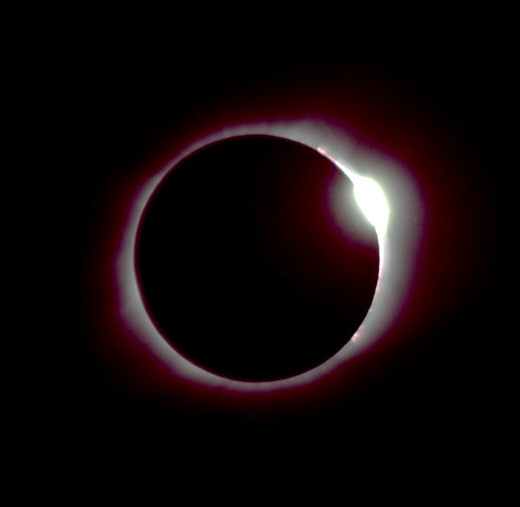

Totality-20170821UT--0007-004ms-Converted-Edited-DiamondRing.jpg

### 2017-Aug-28 (Aug-29 UT): Saturn Video

Last Updated 8/30/2017

Very steady seeing (4/5) and good transparency. But, Saturn was very low (20-25 deg elevation; airmass ~2.4-2.9). Best achievable elevation is only 28 deg (airmass ~2.1) at transit!

|  |  |
| --- | --- |
| C:\Users\Steven Hill\AppData\Local\Microsoft\Windows\INetCache\Content.Word\2017-08-29-0351_2-Hill-Saturn-Composite-RGB-Wavelets.png |  |
| 2017-08-02-0401\_5-Hill-Saturn-RGB-Wavelets-WhtBal-Stuff.png | TBD |

Old Jupiter stuff is included as an FYI and to inform predictions for Uranus and Neptune camera settings.

|  |  |  |  |  |  |
| --- | --- | --- | --- | --- | --- |
| Filter | Gamma | Gain | Brightness | Exposure | LT |
| GRN | 50 | 50 | 0 | 68 ms | 9:54 pm |
| BLU | 50 | 50 | 0 | 68 ms | 10:01 pm |
| NUV | 50 | 100 | 0 | 1251 ms | 10:03 am |
| >685 | 50 | 50 | 0 | 122 ms | 10:12 pm |
| >807 | 50 | 50 | 0 | 523 ms | 10:17 pm |
| CH4 | 100 | 100 | 0 | 2200 ms | 10:33 pm |

Some different Saturn exposure times were tried. This table needs to be updated to include them.

|  |  |  |  |  |  |
| --- | --- | --- | --- | --- | --- |
| Filter | Gamma | Gain | Brightness | Exposure | LT |
| BLU | 50 | 70 | 0 | 200 ms |  |
| GRN | 50 | 70 | 0 | 150 ms |  |
| RED | 50 | 70 | 0 | 150 ms |  |
| >685 | 50 | 70 | 0 | 150 ms |  |

I need to:

* Produce various combinations of RGB images
* Document videos and camera settings
* Identify which images have which moons visible
* Determine effects of gains settings for photometry of moons
* Do a polar map for the hexagon (maybe)
* Do a polar map for the rings
* Do an equatorial map for the bands.
* Archive data

**Data Disposition:** TBD

### Fall 2017 Planning

Last Updated 8/31/2017

* Observations
  + Imaging
    - M8 - Lagoon
    - M21 - Trifid
    - M17 - Swan
    - M16 - Eagle
  + Video
    - Neptune
    - Uranus
    - Mu Dra
    - 61 Cyg
    - Zet Her – STF2085
    - 99 Her
    - Eps Lyr
    - BU 648
    - Lam Oph
    - 70 Oph
    - STF 2173
    - Del Ser
  + Spectra
    - Neptune
    - Uranus
* Analysis
  + M31 Multispectral Analysis *ala* M33, M81, M101 etc.
  + Solar Eclipse Movies, ratio analysis, etc.
  + Updated spectral analysis for outer planets

Neptune exposure planning. Saturn is twice as far from the Sun as Jupiter and so has roughly one fourth the surface brightness. To compensate, gain was raised from 50 to 70-75 and exposures were increase by a factor of ~2.2. This suggests the gain increase provided about 4/2.2~1.8 of the needed increase in response.

Neptune is 3 times farther than Saturn and therefore one ninth the surface brightness. If we keep the gain the same (75-ish), we will need exposures of 750 to 1350 ms for BLU, GRN, RED and >685. Exposures of about 3400 ms might work for >807. NUV and 889CH4 images will likely not be feasible. Dark frames might be a good idea.

If we increase the gain to 100, it would probably be a good idea to use dark frames. If we assume that the gain increase can provide a factor of ~2 in signal, the exposures would range from 400 to 700 ms for BLU, GRN, RED and >685. Exposures of about 1700 ms might work for >807. For NUV and CH4, detections might be possible for exposures >10000 ms. While unlikely to provide any spatial resolution, these might be useful for photometry.

Uranus exposure planning. Saturn is twice as far from the Sun as Jupiter and so has roughly one fourth the surface brightness. To compensate, gain was raised from 50 to 70-75 and exposures were increase by a factor of ~2.2. This suggests the gain increase provided about 4/2.2~1.8 of the needed increase in response.

Uranus is 2 times farther than Saturn and therefore one fourth the surface brightness. If we keep the gain the same (75-ish), we will need exposures of 330 to 600 ms for BLU, GRN, RED and >685. Exposures of about 1500 ms might work for >807. NUV and 889CH4 images will likely not be feasible. Dark frames might be a good idea.

If we increase the gain to 100, it would probably be a good idea to use dark frames. If we assume that the gain increase can provide a factor of ~2 in signal, the exposures would range from 160 to 300 ms for BLU, GRN, RED and >685. Exposures of about 900 ms might work for >807. For NUV and CH4, detections might be possible for exposures >10000 ms. While unlikely to provide any spatial resolution, these might be useful for photometry.

## September

### 2017-Sep-06 (Sep-06 UT): Sun – AR 12673

Last Updated 9/7/2017

Steady seeing (3.5/5), but very poor transparency due to wildfire smoke.

|  |  |
| --- | --- |
| C:\Users\Steven Hill\AppData\Local\Microsoft\Windows\INetCache\Content.Word\2017-09-06-2XXX_X-RGB-WhtBal-ClrSmth-Sat200pct-FlatCrop-Wavelets-Sat200pct-HalfSize.jpg | C:\Users\Steven Hill\AppData\Local\Microsoft\Windows\INetCache\Content.Word\2017-09-06-2XXX_X-IGU-WhtBal-ClrSmth-Sat200pct-FlatCrop-Wavelets-HalfSize.jpg |
| 2017-09-06-2XXX\_X-RGB-WhtBal-ClrSmth-Sat200pct-FlatCrop-Wavelets-Sat200pct-HalfSize.jpg | 2017-09-06-2XXX\_X-IGU-WhtBal-ClrSmth-Sat200pct-FlatCrop-Wavelets-HalfSize.jpg |

This region produced major activity. I should provide contemporary images from X-ray and EUV observatories as well as a timeline of activity over a few days prior and subsequent to my observations. This would best be included in the solar report rather than in this annual observation report.

I need to fully document the individual videos and camera settings for this observation.

**Data Disposition:** TBD

## October

### 2017-Oct-07 (Oct-08 UT): Epsilon Lyrae

Last Updated 9/7/2017

Steady seeing (3.5/5), but very poor transparency due to wildfire smoke.

|  |  |
| --- | --- |
| C:\Users\Steven Hill\AppData\Local\Microsoft\Windows\INetCache\Content.Word\2017-09-06-2XXX_X-RGB-WhtBal-ClrSmth-Sat200pct-FlatCrop-Wavelets-Sat200pct-HalfSize.jpg | C:\Users\Steven Hill\AppData\Local\Microsoft\Windows\INetCache\Content.Word\2017-09-06-2XXX_X-IGU-WhtBal-ClrSmth-Sat200pct-FlatCrop-Wavelets-HalfSize.jpg |
| 2017-09-06-2XXX\_X-RGB-WhtBal-ClrSmth-Sat200pct-FlatCrop-Wavelets-Sat200pct-HalfSize.jpg | 2017-09-06-2XXX\_X-IGU-WhtBal-ClrSmth-Sat200pct-FlatCrop-Wavelets-HalfSize.jpg |

### 2017-Oct-10 (Oct-11 UT): Double Stars, Neptune and Triton

Last Updated 9/7/2017

Steady seeing (3.5/5), but very poor transparency due to wildfire smoke.

|  |  |
| --- | --- |
| C:\Users\Steven Hill\AppData\Local\Microsoft\Windows\INetCache\Content.Word\2017-09-06-2XXX_X-RGB-WhtBal-ClrSmth-Sat200pct-FlatCrop-Wavelets-Sat200pct-HalfSize.jpg | C:\Users\Steven Hill\AppData\Local\Microsoft\Windows\INetCache\Content.Word\2017-09-06-2XXX_X-IGU-WhtBal-ClrSmth-Sat200pct-FlatCrop-Wavelets-HalfSize.jpg |
| 2017-09-06-2XXX\_X-RGB-WhtBal-ClrSmth-Sat200pct-FlatCrop-Wavelets-Sat200pct-HalfSize.jpg | 2017-09-06-2XXX\_X-IGU-WhtBal-ClrSmth-Sat200pct-FlatCrop-Wavelets-HalfSize.jpg |

### 2017-Oct-14 (Oct-15 UT): Veil Nebula, M31 Wide-Field

Last Updated 9/7/2017

Steady seeing (3.5/5), but very poor transparency due to wildfire smoke.

|  |  |
| --- | --- |
| C:\Users\Steven Hill\AppData\Local\Microsoft\Windows\INetCache\Content.Word\Veil-20171015UT-501OIII-sum0h30m-Log-HalfSize.jpg | C:\Users\Steven Hill\AppData\Local\Microsoft\Windows\INetCache\Content.Word\2017-09-06-2XXX_X-IGU-WhtBal-ClrSmth-Sat200pct-FlatCrop-Wavelets-HalfSize.jpg |
| Veil-20171015UT-501OIII-sum0h30m-Log-HalfSize.jpg | 2017-09-06-2XXX\_X-IGU-WhtBal-ClrSmth-Sat200pct-FlatCrop-Wavelets-HalfSize.jpg |
| C:\Users\Steven Hill\AppData\Local\Microsoft\Windows\INetCache\Content.Word\M31-20171015UT-486HIB-sum2h00m-Log-HalfSize.jpg | C:\Users\Steven Hill\AppData\Local\Microsoft\Windows\INetCache\Content.Word\M31-20171015UT-501OIII-sum2h00m-Log-HalfSize.jpg |
| M31-20171015UT-486HIB-sum2h00m-Log-HalfSize.jpg | M31-20171015UT-501OIII-sum2h00m-Log-HalfSize.jpg |

### 2017-Oct-15 (Oct-16 UT): Veil Nebula Wide-Field

Last Updated 10/16/2017

Very good transparency (5/5), but poor seeing (3/5).

|  |  |
| --- | --- |
| C:\Users\Steven Hill\AppData\Local\Microsoft\Windows\INetCache\Content.Word\Veil-20171016UT-501OIII-sum1h00m-Log-HalfSize.jpg | C:\Users\Steven Hill\AppData\Local\Microsoft\Windows\INetCache\Content.Word\Veil-20171016UT-486HIB-sum1h05m-Log-HalfSize.jpg |
| Veil-20171016UT-501OIII-sum1h00m-Log-HalfSize.jpg | Veil-20171016UT-486HIB-sum1h05m-Log-HalfSize.jpg |